# Problem 4. Trifon’s Quest

**Our hero Trifon** was sent on a quest. You are given **his health** and the **map** (as a **rectangle matrix**) where he will travel. Trifon **moves one cell at a time** and the quests **advances with 1 turn (first operate with health points then increase the turns)**. Print the outcome of the quest if it is **successful or not**. A quest is successful if Trifon **goes thru all cells on the map and has health above 0**.

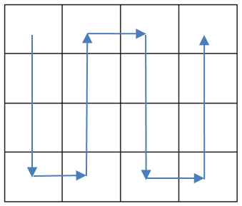There are different **obstacles** on his way.

* **Fight** (F) – the hero **loses {current number of turns} / 2 of his health points**
* **Heal** (H) – the hero **restores {current number of turns} / 3 of his health points**
* **Trap** (T) – the hero must **wait 2 turns**
* **Empty cell** (E) – nothing happens here just game **advances with 1 turn**.

**\* NOTE:** The **division of the turns** must be **integer division**. **For example:** 5 / 2 = 2.

The hero **always starts** his journey in the **top left corner** (the cell with coordinates **[0,0]**). And moves as it’s shown on **the picture**.

## Input / Constrains

* On the **first line** you will receive the **staring** **health points**. **Integer numbers** in range **[0… 231]**
* On the **second line** – **dimensions of the map** in format: “{Rows} {Cols}**”**
* On the next {Rows} **lines** -> the **map** for the journey. **Map** will **contain** **only** the symbols: F, H, T, E

## Output

* In case the player **successfully** finishes the game print:

**Quest completed!**

**Health: {Hero’s current health}**

**Turns: {Total number of turns for the quest}**

* In case the player **did not succeed** in completing the quest print:

**Died at: [{row}, {col}]**

Where **row** and **col** are the coordinates of the cell where the **health** of the hero **becomes ≤ 0**.

## Examples

|  |  |  |  |  |  |  |  |
| --- | --- | --- | --- | --- | --- | --- | --- |
| **Input** | **Output** |  | **Input** | **Output** |  | **Input** | **Output** |
| 10  4 4  FFFF  HHHH  EEEE  EEEE | Quest completed!  Health: 5  Turns: 16 |  | 8  4 3  HHF  FHH  EFT  HHE | Quest completed!  Health: 11  Turns: 16 |  | 50  4 5  TTFFF  EHHFF  THTFF  EHTTT | Died at: [1, 4] |